**TECHNICAL INFORMATION ON A NEW ACCELERATED COMPRESSIVE STRENGTH TEST METHOD FOR CEMENT AND FRESH MIXED CONCRETE**

**Reduces the time to wait for important test results from days to just minutes**

**The challenges we face**

Our Concept – An early warning of quality, practical, fast and cost effective solution for an accelerated testing of cementitious construction building materials.

Within the construction industry, Portland cement and concrete manufacturers and end users, have historically experienced long delays in finding out the strength of cementitious products by using the traditional crush test procedure which takes 28 days for the end result.

Cement prisms or concrete cubes samples need to be taken on site, cured in a temperature-controlled environment, and tested under the compression press; this is an expensive and a time-consuming process before the end results are known.

As concrete hardens in approximately one hour, this forces the end users have to pour practically untested concrete and rely solely on the quality control of the producer or suppliers.

Our concept will provide an early warning solution for manufacturers and their customers to ensure that the quality of the cementitious products are within their requirements**.**

**Innovative conductivity method of testing, description and benefits**

We have created new innovative algorithms and an accelerated method of testing cement and freshly mixed concrete on its compressive and flexural strength, results given within a 5 to 10 minute period.

Incorporating this with our specifically designed probe & instrument ‘ConcTest’ which measures the conductivity of the mixture with a pre-determined amount of cement or freshly mixed concrete mixed with 500 ml of deionised water.

By inputting essential parameters of the sample to calculate its compressive strength at key stages: 2, 3, 7, 14 & 28 days.

This is cost & time effective testing solution for material testing professionals on site with results giving a good indication of the quality of materials they have produced or to be used.

* **Gives users an early warning and quality assurance.**
* **Gives a consistent and fast method of testing**

The testing of the cementitious products by traditional compression crush test, can officially confirm the validity of the accelerated method test results. Our concept together with the traditional crush method will proved reassurance of the quality of the cementitious building materials.

**The obstacles and problems to overcome (Chemical, Mineralogical and Electrical, electronics)**

The theory to utilise conductivity-metrical characteristics to define cement and concrete strength was used by the inventor Mr Akaki Iromashvili, and he was granted a Soviet Union patent in 1982.

After spending several years researching the theory, Mr Akaki found a specific relationship between the electrical conductivity of a water - cement solution, during the early stages of the hydration process, and cement compressive strength.

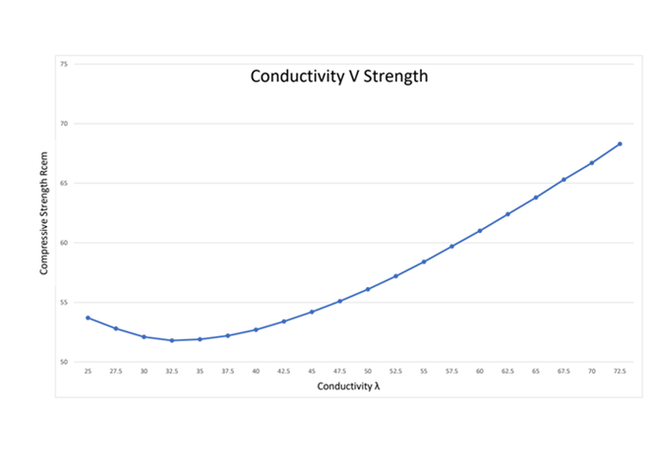

Since CST instruments Ltd was formed in the United Kingdom, Mr. A. Iromashvili (technical consultant) and our team have been developing the concept of an accelerated testing method, bringing it to a commercial reality.

We have tested this concept and developed a method that uses the electro-conductivity reading of a cement/fresh concrete - water mixture in certain proportions to determine their compressive strength indirectly.

The Electro-conductivity is measured with a specifically designed probe, attached to the instrument, that runs a small current of electricity through the mixture.

The Conductivity of the mixture is measured at the early stage of hydration (first 60 seconds). As the cement or concrete reacts with the water it results in the release of positive and negatively charged particles. These make the deionised non-conductive water – conductive.

The amount of released charged particles are relative of the specific conductivity of the mixture. It is accepted as the initial parameter for indicating the chemical composition of the product and is incorporated into the equation.

The strength of cement depends on key physical parameters.

* Density of cement
* Fineness of cement powder
* Consistence of normal paste
* The type and quantity of additive mineral constituents in the cement, according to standard mineral composition of cements (EN BS 197-1)

And then on the curing conditions.

* Curing temperature of samples according to standard laboratory conditions, 20 - 23 C
* Curing time, can be varied according to the project requirements, pre designated time periods of 1, 2, 3, 7, 14 & 28 days

**Testing of cement**

The accelerated testing method itself becomes more precise as different characteristics of the cement are being introduced into the equation. For example: Fineness by Blain test, grinding aid and strength enhancement, mineral additive type, and its impact on strength.

The CemTest instrument has been designed for accelerated testing of cement groups (Portland CEM I and CEM II) with a single mineral additive; In accordance with EN 197 – 1 classification.

Other types of cement, such as: Normal, Rapid, Sulphate resistant and clinkers with a strength enhancement chemical additive can also be tested.

The testing procedure involves measuring the conductivity of a cement & water mixture (15 grams of cement in 500 ml. of deionised water – representing a 3% solution), at the approximate temperature of 20 C.

**Formula Rcem and description of key parameters:**

|  |
| --- |
| **R = Aρλ2ℓn (1.77T+1) (1-(D/100)ν)e -µ√SH λ – 0.0327 √Te 0,0327t + 0.0002 t 2 -0.91√T 3.52 Z** |

This formula involves the following parameters:

**ρ** - Density of cement – defined by Picnometer or Le Chatelier apparatus (**gr / cm3**)

**S** - Fineness of cement powder – defined by Blaine method, (**cm2 / gr**)

**H** - Consistency of normal paste – defined by Vicat apparatus, (**%**)

**D** - Additive size (amount) - 0 to 35 % - according to standard mineral composition of cements (EN BS 197-1)  
**ν**- Influence of additive type impact on cement strength   
**Z** - Water-cement ratio - %  
**t** – Curing temperature – t c  
**T** – Curing time – 1 to 28 days

Our objective is to determine the strength of early stage cement. With modern industry demanding fast and rapid strength indications from 7, 3, 2 or even 1-day periods; we have enhanced, refined, and integrated this into our equation.

The calculation of the cement’s strength, at an early stage, is achieved with the following equation:

**C= 0.6LnLn(4Ts0.125 e-0.004 +1)**



Where:

**T** – Curing time days

**S** – Fineness of cement powder – defined by the Blaine method, (**cm2 / gr**)

**D** – Additive size (amount) - 0 to 35 % - according to standard mineral composition of cements (EN BS 197-1)

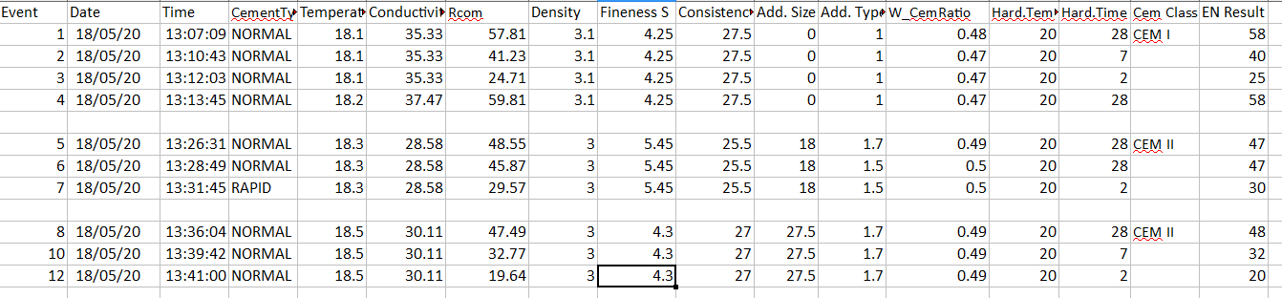

**Example spreadsheet of the CemTest instrument results.**

**Testing of freshly mixed concrete**

To test freshly mixed concrete on its compressive strength currently takes 28 days. It is calculated according to the Classical formula:



Where:

**Q** – Amount of cement in 1 m3 concrete mix

**W** – Water consumption in 1 m3 concrete mix

**A** – Correction coefficients

**C** – Correction for curing temperature

Our formula allows us to calculate the compressive strength, water consumption, and the quantity of cement in freshly mixed concrete in under 10 minutes.

**Q** **= 400 ( + 0.5)**

Where:

**Q** - Amount of cement in 1 m3 concrete mix – Kg, calculated using formula:

 – Concrete mixture conductivity - 24.0 grams/500 ml

 Conductivity of cement - 2 grams/500 ml

 Conductivity of cement - 6 grams/500ml

**To calculate Q**

To calculate the amount of cement in 1 m3 of concrete mix, first measure the conductivity of 2 grams of cement in 500 ml of a deionised water mixture. Add an additional 4 grams of cement into the same mixture after a pre-set period and measure the conductivity again, these are used as key reference parameters, representing 200kg and 600kg of cement in 1 m3 of concrete mix. Next, prepare a freshly mixed concrete sample of 24 grams, sieve through a 10/11 mm (aperture) mesh 2 into 500 ml of deionised water. Mix for a pre-set time and measure the conductivity, this gives the percentage needed to calculate the amount of cement used in 1 m3 of concrete (with up to 10 kg discrepancy).

**To calculate W** -

The water consumption in 1m3 tested concrete mix, requires key parameters of the sample:

**d** – Maximum size of coarse aggregate – mm

**M** – Sand grain module

**X** – Share of fine aggregate %

**L** – Slump test result – cm

**H** – Consistence of cement normal paste – mm

**A** – Aggregate quality and mineral composition

**q** – Impact of plasticiser on concrete strength

**t** – Curing temperature - 5 – 35 C

**T** – Curing time - 28, 7, 3, 2 days

Ensuring the key parameters were entered accurately, this will determine the water consumption, and in turn will give a good indication of the compressive strength of the selected concrete mix.

**Example spreadsheet of ConcTest instrument results**

